**REF - Using TablePress to Create a Table on a WordPress Page**

From <https://wordpress.org/plugins/tablepress/screenshots/>

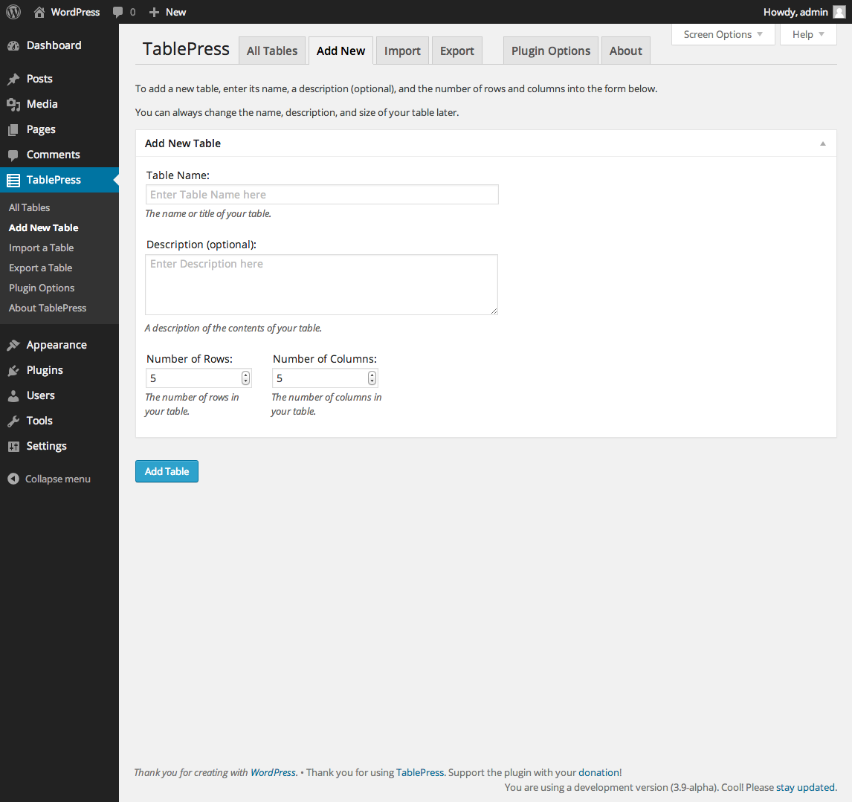

In our case we need only **2 columns** of course.

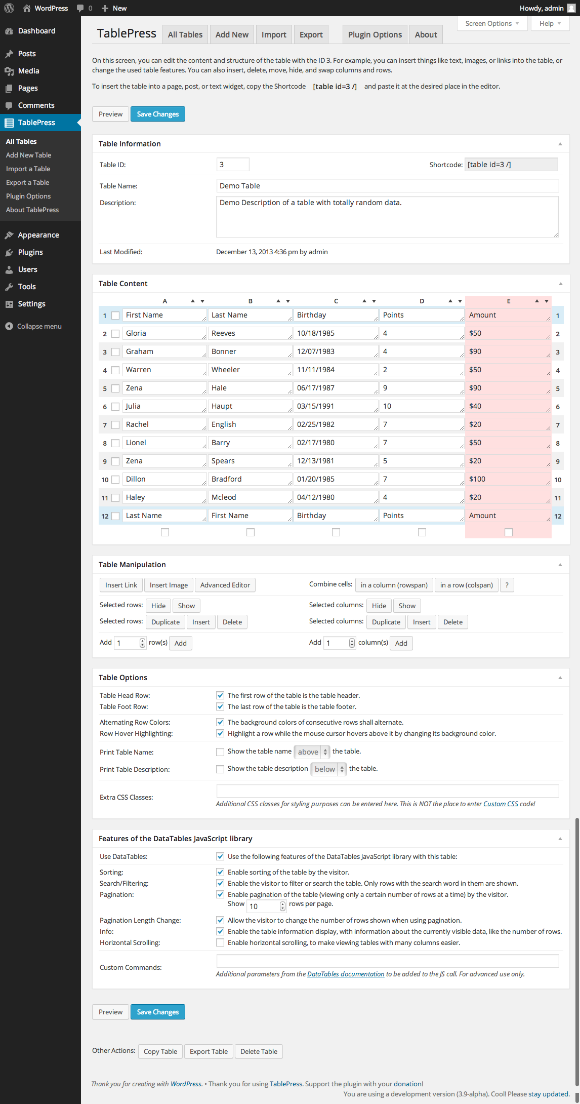

**NOTE:** You will need to ensure that you create actual **links** in your table for the **Useful Links** Page

Here is an example of a link that actually works **and** opens up in a new tab (**target="_blank")**

**<a href="https://www.google.com.au/maps/" target="_blank">https://www.google.com.au/maps/</a>**